Week 7 Tutorial

JavaScript

1. Simple Calculator

Requirement:

1. Create a html page which prompt up two boxes for asking user to input 2 numbers separately:

1. Write a JavaScript Code to add up the two received numbers and show the answer as below:

1. Write a program to collect 3 integers from prompt and show the answer of adding up 3 integers.
2. Save the file as l7q1.html
3. Use if-else statement to do the age checker. User should enter the age in the prompt box, then the webpage will show “you are qualified to drive” if the age is or over 18, otherwise the webpage will show “you are not qualified to drive”.
4. Read positive number n from user, then add up all the number from 1 to n. list the series of numbers and also the sum of all numbers:

1. Leap year checker. Write a webpage that allow user to key in the year and use checker whether it is leap year. You can refer to the chart below to work out the checker:

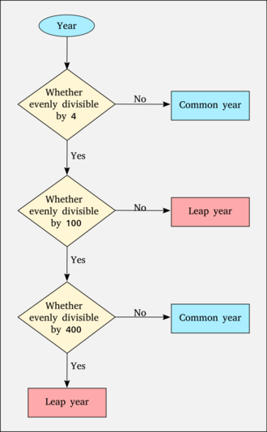

Year = Number(Prompt(…))

if (Year % 4 == 0)

{

if(Year % 100 == 0)

{

if(Year % 400 == 0)

{

print(“leap year”);

}

else

{

print(“common year”);

}

}

else

{

print(“leap year”);

}

}

else

{

print (“common year”);

}

1. Event handler – button click

Sample Code:

|  |
| --- |
| <!DOCTYPE html>  <html>  <body>  <h1>HTML DOM Events</h1>  <h2>The onclick Event</h2>  <p>The onclick event triggers a function when an element is clicked on.</p>  <p>Click to trigger a function that will output "Hello World":</p>  <button onclick="myFunction()">Click me</button>  <p id="demo"> Hello World </p>  <script>  function myFunction() {  document.getElementById("demo").innerHTML = "";  }  </script>  </body>  </html> |

1. <button onclick="myFunction()">Click me</button>

This button is created for user to click in order to perform javascript function myFunction().

1. <p id="demo"></p>

myFunction() result will be shown in this area.

1. function myFunction() {

document.getElementById("demo").innerHTML = "Hello World";

}

This function includes the action print text “hello world”. And these words will be shown in <p id="demo"></p>.

Change background color by clicking a button

Create a webpage with three buttons, when we click the button, the background color will change according to the color selected.

1. Javascript clickable drop-down menu

|  |
| --- |
| <!DOCTYPE html>  <html>  <head>  <meta name="viewport" content="width=device-width, initial-scale=1">  <style>  .dropbtn {  background-color: #3798AE;  color: white;  padding: 16px;  font-size: 16px;  border: none;  cursor: pointer;  }  .dropbtn:hover, .dropbtn:focus {  background-color: #2980B9;  }  .dropdown {  position: relative;  display: inline-block;  }  .dropdown-content {  display: none;  position: absolute;  background-color: #f1f1f1;  min-width: 160px;  overflow: auto;  box-shadow: 0px 8px 16px 0px rgba(0,0,0,0.2);  z-index: 1;  }  .dropdown-content a {  color: black;  padding: 12px 16px;  text-decoration: none;  display: block;  }  .dropdown a:hover {background-color: #ddd;}  .show {display: block;}  </style>  </head>  <body>  <h2>Clickable Dropdown</h2>  <p>Click on the button to open the dropdown menu.</p>  <div class="dropdown">  <button onclick="myFunction()" class="dropbtn">Dropdown</button>  <div id="myDropdown" class="dropdown-content">  <a href="#home">Home</a>  <a href="#about">About</a>  <a href="#contact">Contact</a>  </div>  </div>  <script>  /* When the user clicks on the button,  toggle between hiding and showing the dropdown content */  function myFunction() {  document.getElementById("myDropdown").classList.toggle("show");  }  // Close the dropdown if the user clicks outside of it  window.onclick = function(event) {  if (!event.target.matches('.dropbtn')) {  var dropdowns = document.getElementsByClassName("dropdown-content");  var i;  for (i = 0; i < dropdowns.length; i++) {  var openDropdown = dropdowns[i];  if (openDropdown.classList.contains('show')) {  openDropdown.classList.remove('show');  }  }  }  }  </script>  </body>  </html> |

* Line 5 – line 44 is the css part for adding style to the html page.
* Line 52 is an event trigger, we can use different away to provoke action or performance like onclick, onchange, onmouseover….
* Line 63 to line 65 is the function that will be executed when you click the button.
* Line 68 to line 75 is the function which Close the dropdown if the user clicks outside of it.